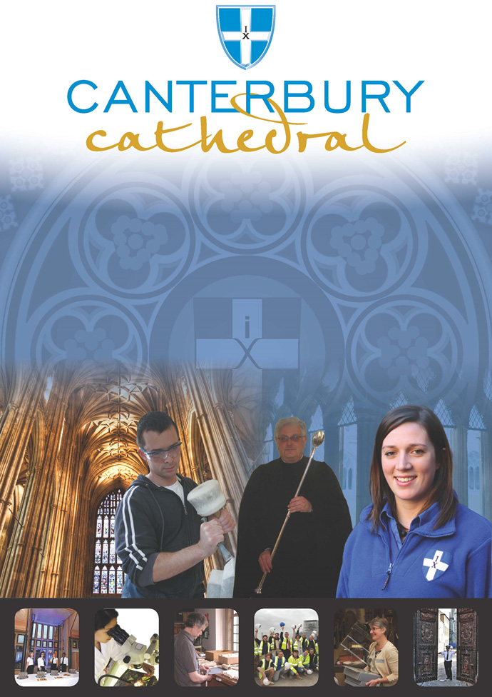

PROFILE OF CANTERBURY CATHEDRAL
St Augustine, the first Archbishop of Canterbury, arrived on the coast of Kent as a missionary to England in 597 AD. He came from Rome, sent by Pope Gregory the Great. It is said that Gregory had been struck by the beauty of Angle slaves he saw for sale in the city market and dispatched Augustine and some monks to convert them to Christianity. Augustine was given a church at Canterbury (St Martin’s, after St Martin of Tours, still standing today) by the local King, Ethelbert whose Queen, Bertha, a French Princess, was already a Christian. This building had been a place of worship during the Roman occupation of Britain and is the oldest church in England still in use. Augustine had been consecrated a bishop in France and was later made an archbishop by the Pope. He established his seat within the Roman city walls (the word cathedral is derived from the Latin word for a chair ‘cathedra’, which is itself taken from the Greek ‘kathedra’ meaning seat.) and built the first cathedral there, becoming the first Archbishop of Canterbury. Since that time, there has been a community around the Cathedral offering daily prayer to God; this community is arguably the oldest organisation in the English speaking world. The present Archbishop, The Most Revd Justin Welby, is 105th in the line of succession from Augustine.
Augustine’s original building lies beneath the floor of the nave– it was extensively rebuilt and enlarged by the Saxons, and the Cathedral was rebuilt completely by the Normans in 1070 following a major fire. There have been many additions to the building over the last nine hundred years, but parts of the quire and some of the windows and their stained glass date from the 12th century.
By 1077, Archbishop Lanfranc had rebuilt it as a Norman church, described as “nearly perfect”. A staircase and parts of the North Wall – in the area of the North West transept also called the Martyrdom – remain from that building.
During the Second World War, the Precincts were heavily damaged by enemy action and the Cathedral’s Library was destroyed. Thankfully, the Cathedral itself was not seriously harmed, due to the bravery of the team of fire watchers, who patrolled the roofs and dealt with the incendiary bombs dropped by enemy bombers.
Today, the Cathedral stands as a place where prayer to God has been offered daily for over 1,400 years; nearly 2,000 services are held each year, as well as countless private prayers from individuals. The Cathedral offers a warm welcome to all visitors – its aim is to show people Jesus, which we do through the splendour of the building as well as the beauty of the worship.

THE WORK OF THE CATHEDRAL
The work of the Cathedral is carried out by over 300 paid staff, supported by some 500 volunteers. The ‘corporate body’ responsible for the management of the Cathedral is the Chapter of Canterbury who are advised by the Cathedral Council and the College of Canons.

The Chapter of Canterbury (Chapter)
The Chapter are responsible for all aspects of the day-to-day management of the Cathedral. Chapter comprises the Dean, the Residentiary Canons, the Receiver General and four additional persons appointed by the Archbishop.

The Cathedral Council
The Council represents the Cathedral community as well as the wider local and regional community. It has 20 members, drawn from a wide variety of organisations. Its duty is to further and support the work of the Cathedral Church in spiritual, pastoral, evangelistic, social and ecumenical areas.

The College of Canons
The College of Canons is composed of 30 Honorary, Lay and Provincial Canons, appointed by the Archbishop and it supports the life of the Cathedral in many different ways.

The Cathedral Trust
The Cathedral Trust is a separate charity that is solely for the benefit of the Cathedral. Since 1974, it has assisted with the restoration, maintenance and improvement of the fabric and contents of Canterbury Cathedral and the provision, promotion and encouragement of music
The Cathedral is well-known all over the world and we welcome more than 1 million visitors and worshippers every year. The Cathedral is more than just a beautiful old building and heritage site; it is a working, living church which maintains a tradition of welcome and worship that has been practiced here for over 1400 years.

Friends
The Friends of Canterbury Cathedral was founded in 1927 by the distinguished scholar and poet Dean George Allen Kennedy Bell. The Organisation was the first of its kind in the world.
The Friends are the Cathedral’s fan club. Admirers of the building, its history and its community, Friends are a part of the Cathedral and work together to preserve it forever, contributing financially - and directly – to many individual and vital projects.

The Cathedral Shop
The Canterbury Cathedral Shop is a large gift shop in the heart of the city of Canterbury. It has an impressive range of high quality gifts, mostly British, and their own exclusive award winning designs.
The Shops wide range of merchandise includes replica historical artefacts, books and CD’s of the world-famous Canterbury Cathedral choir.

Archives & Library Department
Head of Archives and Library
(Cathedral Archivist)

Assistant Archivist

Librarian

Digitisation Officer

Archives and Library Assistants:
- Printed Books

- Public Services

- Strongroom

JOB PROFILE
The Assistant Archivist reports directly to the Head of Archives and Library (Cathedral Archivist).

PURPOSE
To assist with the management and care of the Cathedral’s archive and manuscript collections, the promotion of access to them and the provision of services.

PRINCIPAL TASKS
- As part of the Archives and Library team, contribute to the management of the archive and manuscript collections to the highest possible standards.
- Document the appraisal, accessioning and cataloguing of archive material using CALM software.
- Progress the management of digital records.
- Review and catalogue records archived by departments, in line with safeguarding and data protection requirements.
- Review City Council modern records, under the terms of the agreement with Canterbury City Council.
- Maintaining the representation of the collection on the Archives Hub and Discovery.
- Manage and maintain the Collections Access Database, producing reports.
- Manage identified volunteers working in the Archives and supervise identified work experience placements.
- Contribute towards the supervision and training of other Archives and Library staff and volunteers.
- As part of the Archives and Library team, contribute to the provision of high quality reader services.
- Promote and interpret the archives collections by contributing towards educational and outreach work.
- Contribute to departmental plans to support The Canterbury Journey.
- Maintain an awareness of developments in the archives and records management sectors and demonstrate a commitment to continued professional development.
- Assist with Health and Safety matters as appropriate.
- Ensure that professionalism and confidentiality is maintained at all times.
- Carry out any other reasonable task as required.

PERSON SPECIFICATION
The personal specification below indicates the qualifications, experience, knowledge and skills required to undertake the role effectively.

ESSENTIAL KNOWLEDGE AND SKILLS
- Professional archives qualification or equivalent experience.

- Educated to degree level.

- Excellent IT skills, including experience of archives or library application software.

- Experience of working with medieval and early modern archive material.

- Excellent standard of written English.

- Good knowledge of sources for church and local history.

- Good skills in medieval and early modern palaeography.

- Understanding of and sympathy with the aims and purposes of the Cathedral, its mission and ministry.

DESIRABLE KNOWLEDGE AND SKILLS
- Experience of staff and/or volunteer management.

- Good understanding of Latin.

- Membership of the Archives and Records Association.

PERSONAL ATTRIBUTES
- Enthusiastic and self-motivating.

- Articulate with excellent communication and interpersonal skills.

- Numerate and methodical.

- Ability to multi task and pay attention to detail.

- Able to work to strict deadlines, work flexibly and extended hours when necessary.

TERMS AND CONDITIONS

Duration

This post is offered on a fixed term basis, currently until March 2020.

Grade
5

Salary
Circa £22,450 per annum.

Working hours

Approximately 35 hours per week Monday to Friday 09.00hrs to 17.00hrs. The position holder should be flexible in their approach to hours worked as these will be dictated by operational needs. It is also a requirement of this position to work certain Saturdays per annum on a rota basis normally 9.00hrs to 13.00hrs.

Annual Holiday

Based upon the working hours stated above, the annual entitlement is 25 days plus 8 public holidays and 2 Chapter days.

Training
Training needs are assessed continuously and appropriate on the job training is provided.

Pension scheme
The Chapter of Canterbury offer a Stakeholder pension to all employees. Your age and salary will determine if you are to be automatically enrolled into the pension scheme. The Chapter of Canterbury contribute 7½ % of salary into a Stakeholder Pension Scheme. Staff in the pension scheme are insured against death in service 3 x annual salary to the age of 70.

Parking

Chapter is not able to offer staff parking on site.

Workwear
Dust coats and cotton gloves can be provided as required.

Staff benefits
We are able to offer a range of staff benefits including discounts in local shops, restaurants and sports centres.

Additional Requirements
None.

Processing your personal information
As your employer, The Chapter of Canterbury is required to keep and process information about you for normal employment purposes. The information we hold and process will be used for management and administrative use only. To comply with the General Data Protection Regulations, your acceptance of these terms and conditions gives your consent for your data to be processed.

EQUALITY STATEMENT

The Chapter of Canterbury recognises that discrimination and victimisation is unacceptable and that it is in the interests of the organisation and its employees to utilise the skills of the total workforce. It is the aim of the organisation is to ensure that no employee or job applicant receives less favourable facilities or treatment (either directly or indirectly) in recruitment or employment on grounds of age, disability, gender / gender reassignment, marriage / civil partnership, pregnancy / maternity, race, religion or belief, sex, or sexual orientation.

Updated July 2018
This job description is provided to assist the post holder to know their principal duties. It may be amended from time to time in consultation with you, by, or on behalf of, the Head of the Department, without change to the level of responsibility appropriate to the grading of the post.

HOW TO APPLY

A CV should be submitted on line via our web page.

Application details can be found at:

http://canterbury-cathedral.org/get-involved/employment/vacancies

The closing date for this post is:

Sunday 26th August 2018

Interviews are expected to take place:

Monday 10th September 2018

